

**Club Developer Report**

**Nottinghamshire RFU Meeting**

**Club Support**

Club support is ongoing, I am having a mixture of face to face and virtual meetings with clubs about their 22/23 objectives to review progress and discuss 23/24 plans. I recently visited Ashfield RFCS to see what progress had been made with their facility project and have also had meetings with Nottingham Rugby, Nottinghamshire Hurricanes, Bingham, Notts Casuals, East Leake and a virtual meeting with East Retford RFC. A reminder below of identified Nottinghamshire club needs for 22/23:

**Coaching Courses**

I attended a virtual meeting ran by Scott Johnson RFU Coach Developer for NLD clubs on 15th Feb targeted at Club Coach Coordinators. There was some important information shared with clubs, a summary of this is below:

*As mentioned during the call, our intention is to collate the Training needs of all Clubs, Schools, Colleges and Universities nationally by the 1st April 2023. Once we have determined the needs of each institution, we will then begin to create a Training Programme to support all Coaches and Match Officials. To notify us of the Training Needs at your institution, please complete the following survey by no later than* ***1st April 2023****:*

[*Midlands Training Needs 23/24*](https://forms.office.com/e/BL9t0xpdYv)

***Training Reports***

*To enable us to best plan the Training Programme, we will be comparing the information you provide, with that on GMS. Please ensure that your Training Report is up to date so we see the individual Coaches and Match Officials that require Training. As highlighted on the call, you will be able to do this by assigning the role of ‘Coach’ or ‘Match Official’ to the individual and then adding them to a team. Guides on how to do this below:*

[*Assign Coach/ Match Official to a Team*](https://help.rfu.com/support/solutions/articles/15000042284-assign-and-remove-a-coach-team-manager-to-a-team)

[*Running a Club Training Report*](https://help.rfu.com/support/solutions/articles/15000073656-pulling-reports-from-organisation-profile-club-admins)

***Further Support Resources***

*To support you with identifying appropriate courses for your coaches, please see below resources:*

[*Which England Rugby Training Course is right for me?*](https://www.youtube.com/watch?v=Finc6FuHQHY&embeds_euri=https%3A%2F%2Fwww.englandrugby.com%2F&feature=emb_imp_woyt)

[*Training Course Booklet*](https://www.englandrugby.com/dxdam/94/94667d43-cdca-425a-98c1-bcfde5ab07e6/England%20Rugby%20Training%20Courses%202022-23.pdf)

*First Aid:* [*https://keepyourbootson.co.uk/rugbysafe-toolkit/community-rugby-first-aid-provision-and-information/*](https://keepyourbootson.co.uk/rugbysafe-toolkit/community-rugby-first-aid-provision-and-information/)

*Advanced Award (ERACA):  Click* [*here*](https://www.workcast.com/register?cpak=3074949016536265)

*Introduction to Refereeing:* [*https://keepyourbootson.co.uk/referee-toolkit/training-development-courses/*](https://keepyourbootson.co.uk/referee-toolkit/training-development-courses/)

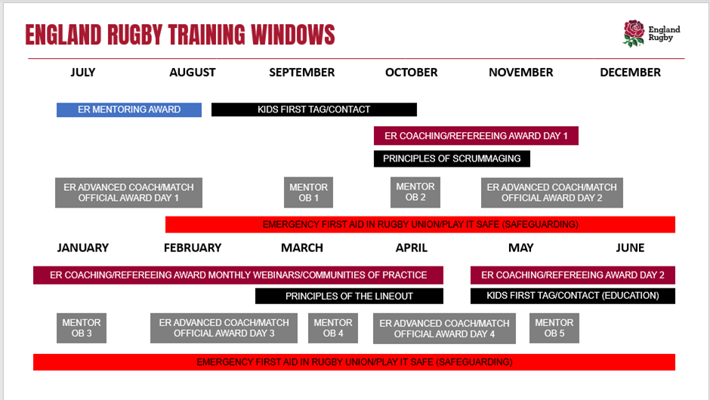

**Courses:**

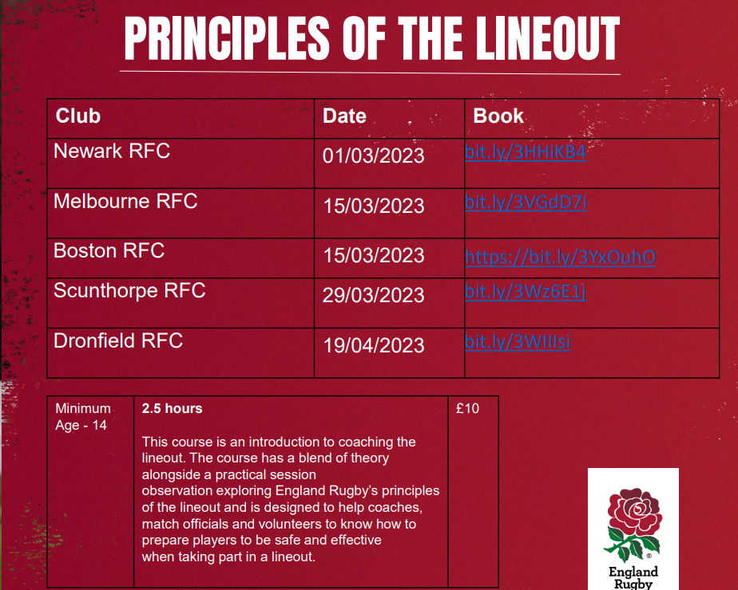

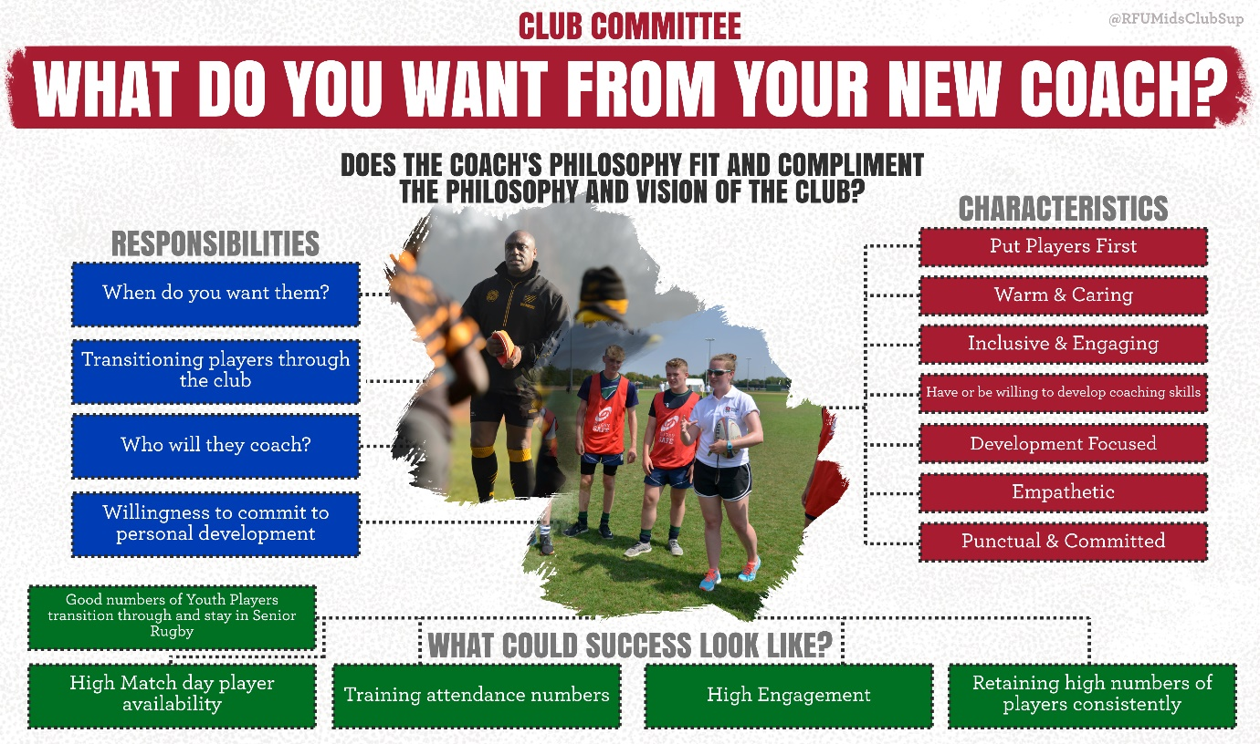

We have seen a number of clubs advertising for coaches for next season, it is worth considering what you want from your new coach.

**Webinars:**

|  |  |  |
| --- | --- | --- |
| **DATE & TIME** | **TOPIC** | **REGISTRATION LINK** |
| 5th April 6.30pm | GMS technical support | <https://us06web.zoom.us/meeting/register/tZErcuiorjkuGNLoUAMtyFr_x3vT4g7AXOlR> |
| 18th April 7pm | Developing a W&Gs Club Strategy | <https://us06web.zoom.us/meeting/register/tZMvfuGspjMjGN1A764twqdbvZnPakqMgTpn> |

**Other**

* I have been working with the NLD Youth Council to support their various projects, there is good representation from Nottinghamshire clubs including Mansfield & West Bridgford and they are a credit to their clubs.
* The volunteer Recruitment Project deadline is 24th March, clubs can apply for £500 to support work around volunteer recruitment, for more information and to apply go to: <https://www.englandrugby.com/participation/volunteers/recruit-and-retain-volunteers> (West Bridgford, Newark & Worksop so far)
* Honda Volunteer of the Year nominations have now closed – East Retford, Notts Casuals, Notts Corsairs & Notts Moderns all put in nominations.
* The Papa Johns Cup starts Sat 1st April, the following Notts teams have entered: Ashfield, Keyworth, Mansfield, Mellish, Newark, Moderns, Casuals, Paviors, Southwell & West Bridgford.
* The Tackle Height Survey closes on 22nd March - <https://survey2.yougov.com/vgS4Y8mGMSjfxm>
* The Age Grade Playing Calendar 23/24 will be going on the website this week: <https://www.englandrugby.com/participation/coaching/age-grade-rugby/playing-calendar>

**Club Help Portal**

Just a reminder that the first port of call for club support is the ‘club support portal’ <https://help.rfu.com/support/home> here you will find loads of pre populated solutions and if you don’t find the answer to your question you can raise a ticket and someone will respond to you within a few hours.

Best of luck with the remainder of the season and please feel free to contact me anytime:

**My contact details are:** [**jennabonser@rfu.com**](mailto:jennabonser@rfu.com) **/ 0792128334**

**Recruit and Retain grant to Nottinghamshire Clubs**

In late October /early November 2022 33 NLD clubs completed a Club Action Plan outlining the priority actions to move their club forward. Please see below a summary slide of the main club development areas that NLD Clubs identified and the spreadsheet at the top of this report

You will see from this slide that Adult male recruitment and retention (including transitioning Colts) was high on the agenda of 33 clubs. As one of 10 clubs in Nottinghamshire to identify this need funding was made available to Nottinghamshire RFU from NLDRFU to develop a planned project for retaining and recruiting adult players for their club.

PDFs were provided support to a plan clubs were asked to complete (also available on NLDs website) to claim a grant to deliver what they intend to do. If all 10 clubs applied the grant available would be £300 which the club had to match on a £4£ basis. The plan was to be completed by the end of January for delivery throughout 2023 including the lead in to the 2023-24 World Cup season. Clubs were asked to provide names of the club group that will lead on the delivery of their plan which would include senior/colt coaches and a senior/colt playing groups.

Nottinghamshire RFU confirmed that they would match fund any grant awarded.

 5 clubs applied for the grant and provided the paperwork. East Leake RFC .Newark RFC, East Retford RFC ,Nottingham Moderns RFC and Bingham RFC received a total of £1000 each. The 5 clubs that did not apply were written to ask if they would take up a grant of £250 for a Player Welfare programme. Keyworth RFC applied and were awarded the grant. Nottingham Corsairs said they did not require a grant and the remaining 2 clubs did not reply. Nottinghamians have since asked for support.

Jeff Mapp

March 2023.