

**Club Developer Report**

**Derbyshire RFU Meeting 20/3/23**

**Club Support**

Club support is ongoing, I am having a mixture of face to face and virtual meetings with clubs about their 22/23 objectives to review progress and discuss 23/24 plans. I recently visited Belper RFC to see what progress had been made with their facility project and spoke with a number of clubs at the NLD event at Newark on 6th March including Bakewell, Chesterfield & Ashbourne. A reminder below of identified Derbyshire club needs for 22/23:

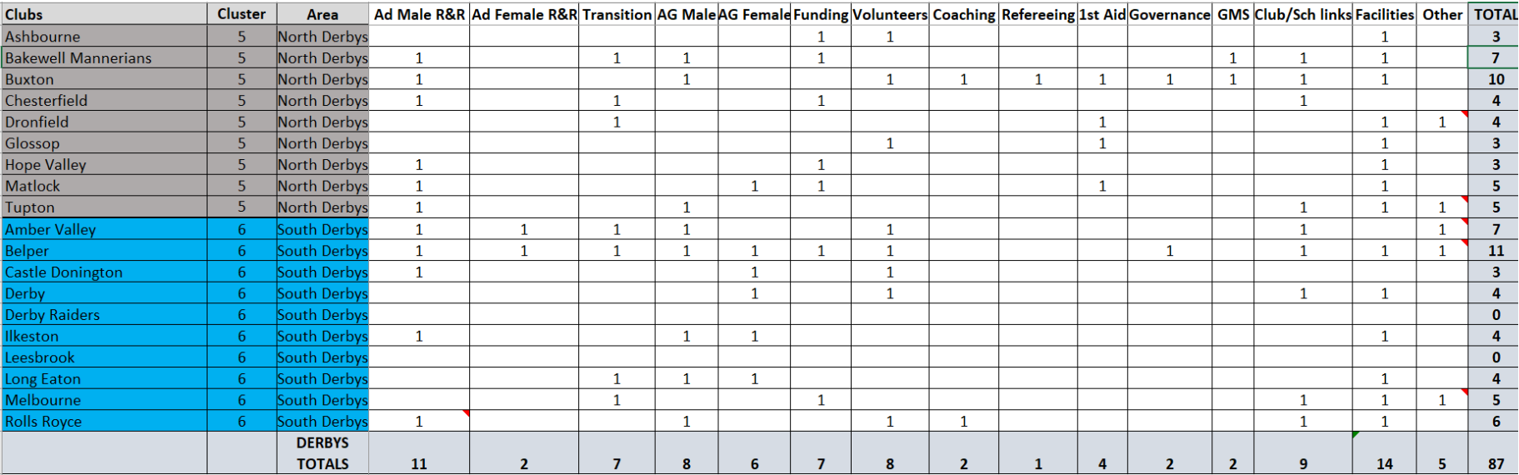

**Coaching Courses**

I attended a virtual meeting ran by Scott Johnson RFU Coach Developer for NLD clubs on 15th Feb targeted at Club Coach Coordinators. There was some important information shared with clubs, a summary of this is below:

*As mentioned during the call, our intention is to collate the Training needs of all Clubs, Schools, Colleges and Universities nationally by the 1st April 2023. Once we have determined the needs of each institution, we will then begin to create a Training Programme to support all Coaches and Match Officials. To notify us of the Training Needs at your institution, please complete the following survey by no later than* ***1st April 2023****:*

[*Midlands Training Needs 23/24*](https://forms.office.com/e/BL9t0xpdYv)

***Training Reports***

*To enable us to best plan the Training Programme, we will be comparing the information you provide, with that on GMS. Please ensure that your Training Report is up to date so we see the individual Coaches and Match Officials that require Training. As highlighted on the call, you will be able to do this by assigning the role of ‘Coach’ or ‘Match Official’ to the individual and then adding them to a team. Guides on how to do this below:*

[*Assign Coach/ Match Official to a Team*](https://help.rfu.com/support/solutions/articles/15000042284-assign-and-remove-a-coach-team-manager-to-a-team)

[*Running a Club Training Report*](https://help.rfu.com/support/solutions/articles/15000073656-pulling-reports-from-organisation-profile-club-admins)

***Further Support Resources***

*To support you with identifying appropriate courses for your coaches, please see below resources:*

[*Which England Rugby Training Course is right for me?*](https://www.youtube.com/watch?v=Finc6FuHQHY&embeds_euri=https%3A%2F%2Fwww.englandrugby.com%2F&feature=emb_imp_woyt)

[*Training Course Booklet*](https://www.englandrugby.com/dxdam/94/94667d43-cdca-425a-98c1-bcfde5ab07e6/England%20Rugby%20Training%20Courses%202022-23.pdf)

*First Aid:* [*https://keepyourbootson.co.uk/rugbysafe-toolkit/community-rugby-first-aid-provision-and-information/*](https://keepyourbootson.co.uk/rugbysafe-toolkit/community-rugby-first-aid-provision-and-information/)

*Advanced Award (ERACA):  Click* [*here*](https://www.workcast.com/register?cpak=3074949016536265)

*Introduction to Refereeing:* [*https://keepyourbootson.co.uk/referee-toolkit/training-development-courses/*](https://keepyourbootson.co.uk/referee-toolkit/training-development-courses/)

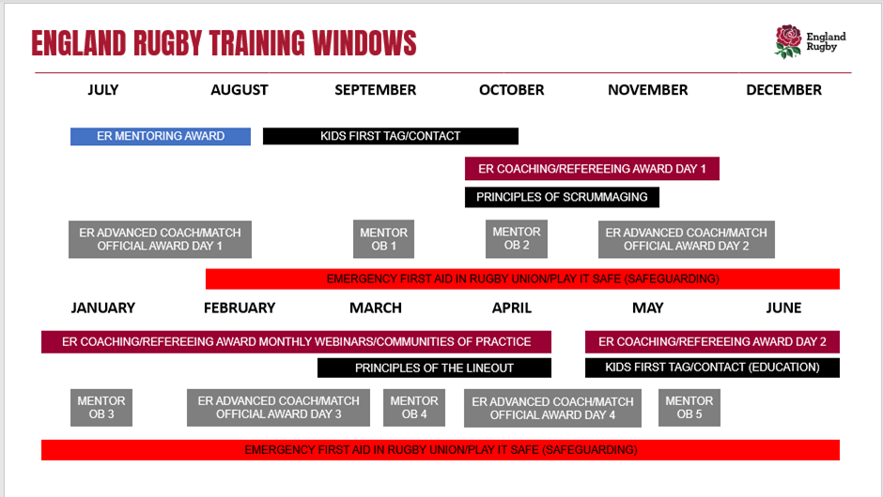



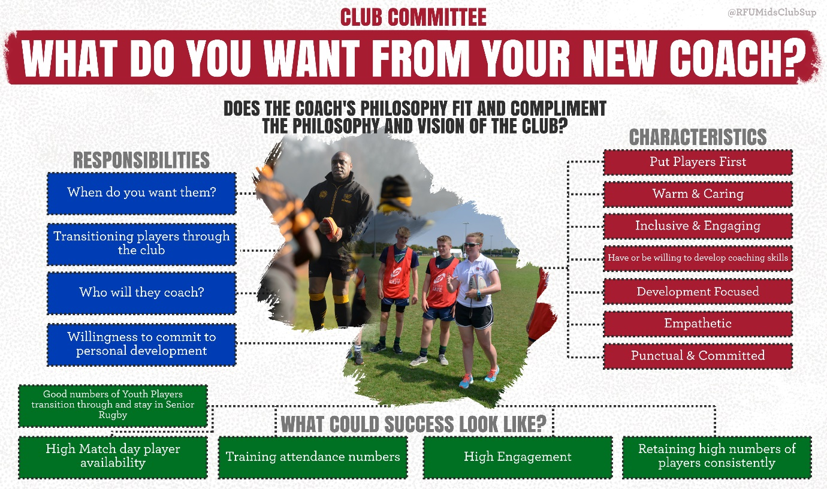

We have seen a number of clubs advertising for coaches for next season, it is worth considering what you want from your new coach.

|  |  |  |
| --- | --- | --- |
| **DATE & TIME** | **TOPIC** | **REGISTRATION LINK** |
| 5th April 6.30pm | GMS technical support | <https://us06web.zoom.us/meeting/register/tZErcuiorjkuGNLoUAMtyFr_x3vT4g7AXOlR> |
| 21st March 7pm | Puberty & Sport | <https://us02web.zoom.us/webinar/register/WN_RFHGfkFWQReygWBApiC1kw> |
| 18th April 7pm | Developing a W&Gs Club Strategy | <https://us06web.zoom.us/meeting/register/tZMvfuGspjMjGN1A764twqdbvZnPakqMgTpn> |

**Other**

* I attended the Derbyshire Schools Conference on 10th Feb to speak to teachers from both Primary and Secondary schools across the County to explain the rugby offer, what support is available and provided a list of clubs and contacts.
* I have been working with the NLD Youth Council to support their various projects, there is good representation from Derbyshire clubs including Ashbourne, Dronfield, Long Eaton & Melbourne, they are a credit to their clubs.
* The volunteer Recruitment Project deadline is 24th March, clubs can apply for £500 to support work around volunteer recruitment, for more information and to apply go to: <https://www.englandrugby.com/participation/volunteers/recruit-and-retain-volunteers> (Long Eaton & Chesterfield have applied so far).
* Honda Volunteer of the Year nominations have now closed - Amber valley, Ashbourne, Long Eaton & Tupton all put in nominations.
* The Papa Johns Cup starts Sat 1st April, the following Derbys teams have entered: Ashbourne, Bakewell, Belper, Derby, Dronfield, Glossop, Ilkeston, Long Eaton, Matlock, Melbourne, Rolls- Royce & Tupton.
* The Tackle Height Survey closes on 22nd March - <https://survey2.yougov.com/vgS4Y8mGMSjfxm>
* The Age Grade Playing Calendar 23/24 will be going on the website this week: <https://www.englandrugby.com/participation/coaching/age-grade-rugby/playing-calendar>
* Only 2 clubs applied for the recent offer of funding to support with adult male recruitment & retention so Buxton & Tupton have been awarded £500 each plus every club has been offered £150 towards 1st aid qualifications to support the adult game.

**Club Help Portal**

Just a reminder that the first port of call for club support is the ‘club support portal’ <https://help.rfu.com/support/home> here you will find loads of pre populated solutions and if you don’t find the answer to your question you can raise a ticket and someone will respond to you within a few hours.

Best of luck with the remainder of the season and please feel free to contact me anytime:

**My contact details are:** [**jennabonser@rfu.com**](mailto:jennabonser@rfu.com) **/ 07921283344**