Senior CBRM Report – NLD RU, 2nd December 2024.
RFU Reports:
It’s been highlighted to me that my reports are sometimes being shared with Clubs as part of minutes more widely than the CB Management, again this is something we encourage however elements of my report are sensitive, so I’ve highlighted (in grey) these elements to be removed prior to sharing with Clubs etc.
FOR ACTION/DISCUSSION:
Adult Player Registration:
New report produced this week, 3,807 players registered in the Men’s Game both Club & RFU, 782 total in the Women’s game – TOTAL overall: 4,598 (last report - 4,223).
Report from 28/11/24:
Club (MALE) | League Level | Club Registered | RFU Registered | Grand Total | Club (FEMALE) | League Level | Club Registered | RFU Registered | Grand Total
Amber Valley RUFC | 9 | 43 |  | 43 | Amber Valley RUFC | 9 | 29 |  | 29
Ashbourne RUFC | 8 | 9 | 112 | 121 | Ashbourne RUFC | 8 | 55 |  | 55
Ashfield RFC | 8 | 18 | 47 | 65 | Ashfield RFC | 8 | 26 |  | 26
Bakewell Mannerians RUFC | 9 | 34 |  | 34 | Bakewell Mannerians RUFC | 9 | 3 |  | 3
Barton & District RUFC | 100 | 41 |  | 41 | Belper RUFC | 9 | 22 |  | 22
Belper RUFC | 9 | 91 |  | 91 | Boston RFC | 8 | 3 | 46 | 49
Bingham RFC | 9 | 50 | 1 | 51 | Bourne RUFC | 7 | 16 |  | 16
Boston RFC | 8 | 2 | 50 | 52 | Buxton RUFC | 100 | 1 |  | 1
Bourne RUFC | 7 | 1 | 58 | 59 | Chesterfield Panthers RUFC | 9 | 2 |  | 2
Buxton RUFC | 100 | 20 |  | 20 | Cleethorpes RUFC | 9 | 8 |  | 8
Castle Donington RUFC | 9 | 37 | 2 | 39 | Derby RFC | 5 |  | 35 | 35
Chesterfield Panthers RUFC | 9 | 47 |  | 47 | Dronfield RUFC | 6 | 2 |  | 2
Cleethorpes RUFC | 9 | 46 |  | 46 | East Retford RUFC | 9 | 18 |  | 18
Derby RFC | 5 | 24 | 92 | 116 | Gainsborough RUFC | 8 | 25 | 1 | 26
Dronfield RUFC | 6 | 25 | 65 | 90 | Glossop RFC | 7 | 26 | 1 | 27
East Leake RFC | 100 | 35 |  | 35 | Grimsby RUFC | 9 | 4 |  | 4
East Retford RUFC | 9 | 41 |  | 41 | Kesteven RUFC | 7 | 30 |  | 30
Gainsborough RUFC | 8 | 4 | 57 | 61 | Lincoln RFC | 7 |  | 39 | 39
Glossop RFC | 7 | 22 | 56 | 78 | Long Eaton RFC | 5 | 3 | 58 | 61
Grimsby RUFC | 9 | 81 |  | 81 | Mansfield RUFC | 7 | 39 |  | 39
Horncastle RFC | 100 | 36 |  | 36 | Market Rasen & Louth RUFC | 7 | 14 |  | 14
Ilkeston RUFC | 6 | 30 | 72 | 102 | Melbourne RFC | 6 | 1 |  | 1
Kesteven RUFC | 7 | 30 | 61 | 91 | Mellish RFC | 6 | 26 |  | 26
Keyworth RFC | 8 | 15 | 60 | 75 | Newark RUFC | 6 | 49 |  | 49
Leesbrook RUFC | 9 | 36 |  | 36 | North Hykeham RUFC | 9 | 6 |  | 6
Lincoln RFC | 7 | 62 | 46 | 108 | Nottingham Casuals RFC | 8 | 15 |  | 15
Long Eaton RFC | 5 | 2 | 98 | 100 | Nottingham Corsairs RFC | 100 | 8 |  | 8
Mansfield RUFC | 7 | 17 | 98 | 115 | Nottingham Moderns RFC | 7 | 2 |  | 2
Market Rasen & Louth RUFC | 7 | 42 | 64 | 106 | Nottingham RFC | 2 | 1 |  | 1
Matlock RUFC | 6 | 10 | 94 | 104 | Paviors RFC | 6 | 26 |  | 26
Meden Vale RFC | 9 | 42 |  | 42 | Rolls-Royce RFC | 9 | 1 |  | 1
Melbourne RFC | 6 | 18 | 83 | 101 | Scunthorpe RFC | 5 | 34 |  | 34
Mellish RFC | 6 | 16 | 79 | 95 | Sleaford RFC | 9 | 2 |  | 2
Newark RUFC | 6 | 24 | 101 | 125 | Spalding RFC | 7 | 2 |  | 2
North Hykeham RUFC | 9 | 95 |  | 95 | Stamford Rugby | 7 |  | 47 | 47
Nottingham Casuals RFC | 8 | 32 | 59 | 91 | Tupton RUFC | 9 | 3 |  | 3
Nottingham Corsairs RFC | 100 | 7 |  | 7 | West Bridgford RFC | 6 | 10 | 43 | 53
Nottingham Moderns RFC | 7 | 2 | 111 | 113
Nottingham RFC | 2 | 2 | 35 | 37
Nottinghamians RFC | 9 | 39 |  | 39
Nottinghamshire Hurricanes RFC | 100 | 9 |  | 9
Ollerton RFC | 9 | 51 |  | 51
Paviors RFC | 6 | 29 | 84 | 113
Rolls-Royce RFC | 9 | 46 |  | 46
Scunthorpe RFC | 5 | 51 | 47 | 98
Skegness RUFC | 9 | 49 |  | 49
Sleaford RFC | 9 | 49 |  | 49
Southwell RFC | 7 | 38 | 78 | 116
Spalding RFC | 7 | 1 | 76 | 77
Stamford College Old Boys RFC | 9 | 58 |  | 58
Stamford Rugby | 7 | 40 | 57 | 97
Tupton RUFC | 9 | 77 |  | 77
West Bridgford RFC | 6 | 15 | 101 | 116
Worksop RUFC | 9 | 22 |  | 22
AGR Registration – report produced 28/11/24:
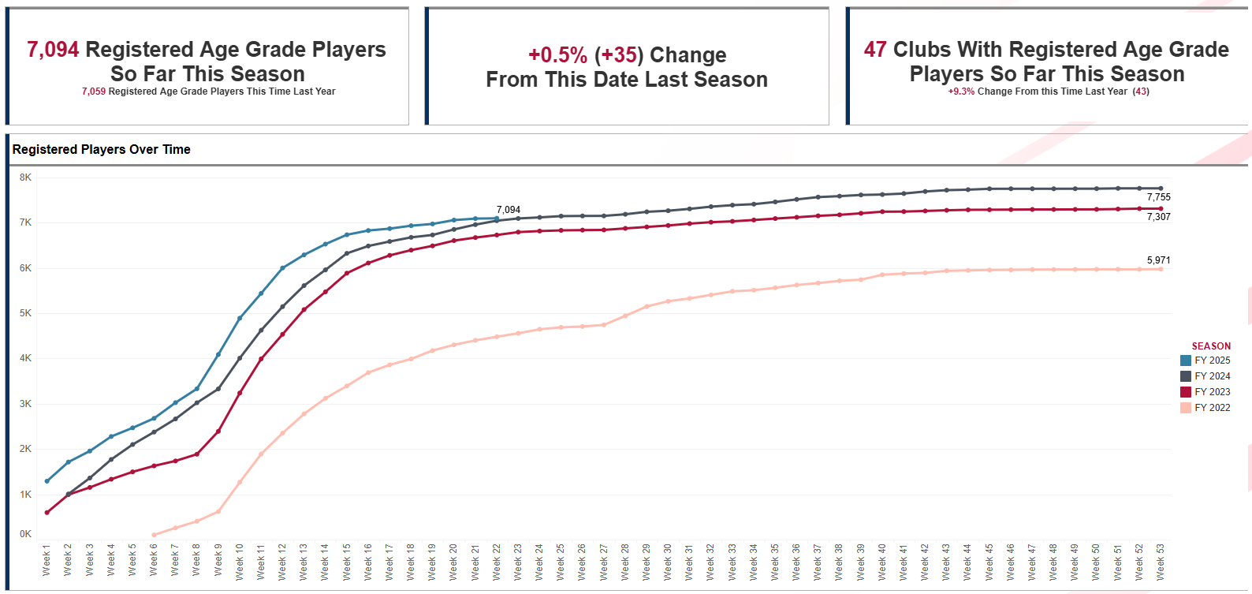
NOTE: Weekly reports on Adult & Age Grade registration are available on the CB Portal, if anyone wishes for a more detailed breakdown please get in touch.
Clubs to monitor in coming weeks – Club Developer in contact:
Chesterfield – multiple issues going on; age demographic, people under 30yrs old drop in and out and don’t commit, only 10 training regularly. Club is arranging meeting to discuss options with the players as current situation is not sustainable. Coaching is an issue, no structure and struggling with the lack of players. ACTIONS – have linked up with Scott Johnson (coach developer) to address coaching issues, chairman is going to feedback post players meeting and have sent them MOGP and resources around adult male recruitment & retention.
East Retford – struggling to get a team out each week, no consistency, if players don’t want to travel or think they may lose not they’re not making themselves available (10 training regularly). Club still don’t value playing to ‘Game On’ rules, coaching not a good standard and getting demotivated, he is also the women’s coach so very worried about losing him. Committee refuses to invest in the players or anything that may support recruitment & retention. ACTIONS – encouraged to apply for volunteer recruitment fund, linked up with Scott Johnson coach developer to support their coach, sent them a package of different membership offers, which may encourage the committee to address this area as well as MOGP and resources around adult male recruitment & retention.
Volunteer Recruitment Programme:
The objectives of the fund are to create new opportunities to recruit volunteers, raise awareness of volunteer opportunities amongst new audiences, and embed volunteer management in clubs working practices. 13 clubs from NLD have applied – these will shortly be shared with the CB for feedback.
FOR INFORMATION:
General Club Developer Update:
- 47 club action plans submitted (see attached).
- Club needs matrix being used by both myself and CB to target clubs for specific support (eg club/school links, transition, adult & age grade recruitment….)
- I am now going through the detail in all the plans to offer bespoke support & follow up.
- Promoted volunteer recruitment fund, women’s leadership programme and National webinars.
- Still encouraging clubs to complete facility audit.
- Working with coach developer to promote courses and looking through the weekly updates to push those courses with low numbers.
- Supporting club visits with facility team on 14th & 15th Jan (7 clubs across Lincs & North Notts).
- Working with Claire Antcliffe on setting up a meeting in late Jan for all emerging women’s teams in NLD (@10 new teams).
- Meeting with East Lincs Council next week to discuss potential opportunities for Grimsby & Cleethorpes.
- Worked with Chris Hall (club developer) to invite Glossop into North Manchester girls league which was well received by the club.
- Met with SRM Nick Robb (Notts) 11th November along with the link clubs, Nottingham Rugby & CB, Nick has provided a plan and followed up actions with link clubs since.
- Held NLD schools meeting at Newark RFC on 25th Nov, new SRM in Lincs Rupert Gibson attended (Nick Robb provided report along with others), positive to see the growth of schools delivery in the area.
- Attended NLD coaches evening at Notts Uni with Paul Westgate, community of coaches group still growing which is positive.
Discipline & Safeguarding CB Reviews 24/25:
Thank you for submitting both reviews. I will be in touch with Kristina shortly to organise a meeting in the New Year with the RFU Safeguarding Team.
RWC Impact 25 Programme:
Small Grant Facility Fund:
The following club has been awarded a small grant to support facility improvements aligned to the Impact 25 Programme, they are still to accept the award currently;
Club | Project | Award (£)
Derby RFC | Changing Room Refresh | £5,000
Focus Clubs:
Jenna Bonser is in contact with those clubs identified as a ‘focus’ for our Impact 25 Programme, accessing various interventions to support the growth of their girls section. Current status/updates highlighted below;
Ashbourne RFC | Have anything between 15-34 girls between u12-u18 currently training, very much down to organic growth. Club have been made aware that they need to get players registered. Clustering with Derbyshire Dragons and exploring post Christmas playing opportunities.  The Club have purchased mobile floodlights, which has improved training offer.  There are some challenges with the Women, the Club Developer has a meeting arranged to discuss. Currently have 55 players so 2 teams. Entered Inner Warrior Series but sadly there have been a few serious injuries, which has prompted some questions regarding structure of the Women’s set up (r.e. creating a 1st and development team or keep everyone together).
Nottingham Casuals RFC | A successful summer touch programme resulted in the recruitment of 40 new girls and 20 women, so the club are progressing towards becoming a ‘full house.’ U9/10s girls playing fixtures and has led to recruitment and retention of minis girls (10 players), u11/12s with 13 girls, u14s with 30 girls, u16s - 18 girls, u18s - 13 girls linked up with Derbyshire Dragons. Had over 30 women train in total, 10-15 doing contact, club looking at playing opportunities post xmas.
Melbourne RFC | (Meeting Tues 26th Nov) Club have recently started women’s team with a core of 12 players with an additional 6 not committing regularly. Coupled with the 11 U18 Girls who will all be eligible to play women’s rugby next season, they have entered IWS for new year. Delivering sessions in local schools to recruit (boys & girls), although concerned about space to allow for growth.
Derby RFC | Meeting to be held on Tuesday 3rd December.
Paviors RFC | Meeting TBC.
Kesteven RFC | Meeting TBC.
Area Training Manager Update:
Headlines from Award window thus far (Midlands specific);
- England Rugby Coaching Award - Bookings: 386 of a possible 475 - booked at 81.2% capacity.
- England Rugby Coaching Award - Attendance: 86% of those booked have attended Day 1.
- England Rugby Coaching Award - 24.6% of those attending are female.
England Rugby Coaching Award - Nottingham University | 11/30/2024 | 27
- England Rugby Referee Award - Bookings: 79 of a possible 179 (inclusive of 3 cancelled courses) - booked at 44.1% Capacity.
- England Rugby Referee Award - Attendance: 96% of those booked have attended Day 1.
- England Rugby Referee Award - 20.8% of those attending are female.
England Rugby Referee Award - Chesterfield RFC | 11/24/2024 | 14
Your continued support in promoting these courses is appreciated – thank you.

